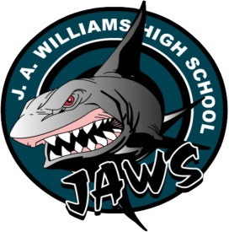

COSMETOLOGY10
Instructor’s Name: Lisa Marouelli
School’s Phone Number: 780 623-4271
Instructor’s e-mail address: lisa.marouelli@nlsd.ab.ca

RESOURCES
- Texts: Milady Standard Cosmetology, Cengage Learning, 2014, Online Tutorials
- Supplies
- School Supplied
- Student Supplied: scribbler, binder, blank and lined paper, pencil and pen. There may be materials the students would like to use for projects and it is there responsibility to provide the materials for their projects

COURSE OBJECTIVES
The goal of Cosmetology 10 is for students to achieve personal wellness by learning about professional and personal hair, skin, and nail care, to obtain confidence and become artistically expressive in the handling of hair, as well as gaining employable skills.

CONTENT
COS 1010: Personal and Professional practice
COS 3000: The Science of Cosmetology EST 1070: Manicure 1
COS 1020: Long Hair Design
HSA 3400: Hair and Scalp Care 1
HSA3430: Hairstyling 1

COURSE EVALUATION
(Criteria and Value)

Student achievement of course outcomes will be evaluated through a triangulation of data that is ongoing from formative and summative assessments throughout the year.
Effective feedback may include scoring guides, rubrics, benchmarks, exemplars, written feedback or checklists that support student achievement and provide summative assessment evidence of learning. Students will be provided with opportunities to replace zeros and incomplete assignments or activities if they display competence on alternative assessments or assignments.

