Science 9 | Unit C
Monitoring Air Quality | 84 mins

Measured in 2 Ways  - measuring the levels of pollutants in the air  - estimating the amount of emissions from pollution sources  Types of Pollutants  - Sulfur Dioxide  Forms Smog and Acid Rain | More Accurate  SO₂  Scrubbers change the SO₂ to a useful chemical Gypsum
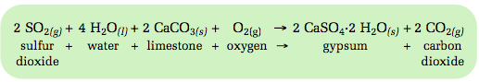
- Nitrogen Oxides  Mixtures of NO₂ and NO gases  Forms Smog and Acid Rain  - Carbon Monoxide  Formed from burning with not enough oxygen  - CFCs  Useful chemical used as a propellant in aerosols and a coolant in fridges  Reacts with UV to make chlorine… destroys the ozone,  - Ozone  - In Atmosphere  - Helps protect the planet  - Ground-Level  - Formed from NO_{x} O and VOCs | NO_{x}  CO  Silent Killer  Chlorofluorocarbons  1 CFC can destroy 100 000 Ozone molecules  O₃  Good Ozone  Bad Ozone  VOC – Volatile Organic Compounds

Greenhouse Gases
- Any gas that helps trap heat on the planet  Carbon Dioxide  - naturally occurring gas  - artificially produced in burning of fuels  Greenhouse Effect  - needed for survival, keeps the planet warm  Enhanced Greenhouse Effect  - too many greenhouse gases can trap too much heat  - May be causing Global Warming | CO₂, H₂O, Methane, Nitrogen Oxides  